DSYS601 – DevOps
Module 03 – Lab 03.01.11
Explore Python Development Tools

Student Name:
Mark Awarded: | / 13

Contents

Item | Description | Page
1. | Objectives | 2
2. | Background / Scenario | 2
3. | Required Resources | 2
4. | Instructions | 2
4.1 | Launch the DEVASC VM | 2
4.2 | Review the Python Installation | 2
4.3 | PIP and Python Virtual Environments | 3
4.3.1 | Create a Python 3 virtual environment | 3
4.3.2 | Activate and test the Python 3 virtual environment | 4
4.4.3 | Check the current packages installed in the system environment | 5
4.4 | Sharing Your Virtual Environment | 6
5 | Student Answers | 11

Note: ALL Answers should be supplied in section 5 (Student Answers).
This is the only part of this document that will be marked.

1. Objectives:

Part 1: Launch the DEVASC VM
Part 2: Review the Python Installation
Part 3: PIP and Python Virtual Environments
Part 4: Sharing Your Virtual Environment

2. Background / Scenario:

This course has some basic expectations for students, that they have some background in Python and some hands-on experience with programming. Lab practice with Python gives your fingers the "muscle memory" to work more efficiently in Python. However, initially it is important for you to know how to maintain a Python development environment. In this lab, you review Python installation, PIP (“PIP installs Packages – a recursive acronym), and Python virtual environments.

3. Required Resources:

- 1 PC with operating system of your choice
- Virtual Box or VMWare
- DEVASC Virtual Machine

4. Instructions:

4.1 Launch the DEVASC VM:

If you have not already completed the Lab - Install the Virtual Machine Lab Environment, do so now. If you have already completed that lab, launch the DEVASC VM.

4.2 Review the Python Installation:

These commands give you basic methods for learning more about the local Python environment.

a. In the DEVASC VM, you can check the version of Python already installed with the python3 -V command.

devasc@labvm:~$ python3 -V

Python 3.8.2

devasc@labvm:~$

- As a form of evidence that you have performed this task, take a graphical “snip” of your work as evidence that you completed this task successfully. Copy this clip into the area provided below:

Answer 01 – Python Version

b. To see the directory for the local Python environment, use the which python3 command.

devasc@labvm:~$ which python3

/usr/bin/python3

devasc@labvm:~$

- As a form of evidence that you have performed this task, take a graphical “snip” of your work as evidence that you completed this task successfully. Copy this clip into the area provided below:

Answer 02 – Python Environment

4.3 PIP and Python Virtual Environments:

PIP stands for Pip Installs Packages. Many people first learn about PIP and start using pip3 install commands on the system wide Python installation. When you run pip3 install command on your system, you might introduce competing dependencies in your system installation that you may or may not want for all Python projects. Therefore, the best practice is to enable a Python virtual environment. Then install only the packages that are needed for the project in that virtual environment. That way, you know exactly which packages are installed in a given setting. You can switch those package dependencies easily when switching to a new virtual environment, and not break or cause problems due to competing versions of software.

To install a Python virtual environment, use the venv tool in Python 3 and then activate the virtual environment, as shown in the following steps.

4.3.1 Create a Python 3 virtual environment.:

a. Inside the DEVASC VM, change to the labs/devnet-src/python directory.

devasc@labvm:~$ cd labs/devnet-src/python/

devasc@labvm:~/labs/devnet-src/python$

b. Enter the following command to use the venv tool to create a Python 3 virtual environment with the name devfun. The -m switch tells Python to run the venv module. The name “devfun” is chosen by the programmer.

devasc@labvm:~/labs/devnet-src/python$ python3 -m venv devfun

devasc@labvm:~/labs/devnet-src/python$

Note: This creates a sub-directory (called “devfun”) with hundreds of files that support a virtualised environment.

- As a form of evidence that you have performed this task, take a graphical “snip” of the folders/files in the devfun directory as evidence that you completed this task successfully. Copy this clip into the area provided below:

Answer 03 – Contents of the devfun directory

4.3.2 Activate and test the Python 3 virtual environment.:

a. Activate the virtual environment. The prompt changes to indicate the name of the environment you are currently working in, which is devfun in this example. Now when you use the pip3 install command form here, the system will only install packages for the active virtual environment.

devasc@labvm:~/labs/devnet-src/python$ source devfun/bin/activate

(devfun) devasc@labvm:~/labs/devnet-src/python$

- As a form of evidence that you have performed this task, take a graphical “snip” of your work as evidence that you completed this task successfully. Copy this clip into the area provided below:

Answer 04 – New Virtual Environment

b. Run the pip3 freeze command to verify that there are no additional Python packages currently installed in the devfun environment. This command outputs a list of all installed Python packages in the current environment along with their exact versions.

(devfun) devasc@labvm:~/labs/devnet-src/python$ pip3 freeze

(devfun) devasc@labvm:~/labs/devnet-src/python$

c. Now install the Python requests package within the devfun environment.

(devfun) devasc@labvm:~/labs/devnet-src/python$ pip3 install requests

Collecting requests
Downloading requests-2.24.0-py2.py3-none-any.whl (61 kB)
|████████████████████████████████| 61 kB 510 kB/s
Collecting idna<3,>=2.5
Downloading idna-2.10-py2.py3-none-any.whl (58 kB)
|████████████████████████████████| 58 kB 5.6 MB/s
Collecting certifi>=2017.4.17
Downloading certifi-2020.6.20-py2.py3-none-any.whl (156 kB)
|████████████████████████████████| 156 kB 19.4 MB/s
Collecting chardet<4,>=3.0.2
Downloading chardet-3.0.4-py2.py3-none-any.whl (133 kB)
|████████████████████████████████| 133 kB 52.1 MB/s
Collecting urllib3!=1.25.0,!=1.25.1,<1.26,>=1.21.1
Downloading urllib3-1.25.9-py2.py3-none-any.whl (126 kB)
|████████████████████████████████| 126 kB 48.5 MB/s
Installing collected packages: idna, certifi, chardet, urllib3, requests
Successfully installed certifi-2020.6.20 chardet-3.0.4 idna-2.10 requests-2.24.0 urllib3-1.25.9

- As a form of evidence that you have performed this task, take a graphical “snip” of your work as evidence that you completed this task successfully. Copy this clip into the area provided below:

Answer 05 – Installing the requests package

d. Re-enter the pip3 freeze command to see the packages now installed in the devfun environment.

Note: Your list of packages and version numbers may be slightly different.

(devfun) devasc@labvm:~/labs/devnet-src/python$ pip3 freeze

certifi==2020.6.20
chardet==3.0.4
idna==2.10
requests==2.24.0
urllib3==1.25.9

(devfun) devasc@labvm:~/labs/devnet-src/python$

- As a form of evidence that you have performed this task, take a graphical “snip” of your work as evidence that you completed this task successfully. Copy this clip into the area provided below:

Answer 06 – List of packages and version as a result of a freeze

e. To deactivate the virtual environment and go back to your system, enter the deactivate command.

(devfun) devasc@labvm:~/labs/devnet-src/python$ deactivate

devasc@labvm:~/labs/devnet-src/python$

- As a form of evidence that you have performed this task, take a graphical “snip” of your work as evidence that you completed this task successfully. Copy this clip into the area provided below:

Answer 07 – Result of a deactivate command

4.4.3 Check the current packages installed in the system environment:

- Enter the system wide python3 -m pip freeze command to see what packages are installed in the system environment. Note, the -m switch instructs Python to run the module as a script using the current interpreter.
This avoids PATH issues.

Note: Because Python 3 is invoked with the following command, you only use pip instead of pip3.

devasc@labvm:~/labs/devnet-src/python$ python3 -m pip freeze

aiohttp==3.6.2
ansible==2.9.9
<output omitted>
zipp==1.0.0

devasc@labvm:~/labs/devnet-src/python$

- As a form of evidence that you have performed this task, take a graphical “snip” of your work as evidence that you completed this task successfully. Copy this clip into the area provided below:

Answer 08 – List of packages and version as a result of a freeze

b. If you want to quickly find the version of a package installed, pipe the output to the grep command. Enter the following to see the version of the requests package currently installed.

devasc@labvm:~/labs/devnet-src/python$ python3 -m pip freeze | grep requests

requests==2.22.0
requests-kerberos==0.12.0
requests-ntlm==1.1.0
requests-toolbelt==0.9.1
requests-unixsocket==0.2.0

devasc@labvm:~/labs/devnet-src/python$

- As a form of evidence that you have performed this task, take a graphical “snip” of your work as evidence that you completed this task successfully. Copy this clip into the area provided below:

Answer 09 – View the requests values

4.4 Sharing Your Virtual Environment:

The output of the pip3 freeze command is in a specific format for a reason. You can use all the dependencies listed so that other people who want to work on the same project as you can get the same environment as yours.

A developer can create a requirements file, such as requirements.txt, by using the pip3 freeze > requirements.txt command. Then another developer can, from another activated virtual environment, use this pip3 install -r requirements.txt command to install the packages required by the project.

a. Re-activate the devfun virtual environment.

devasc@labvm:~/labs/devnet-src/python$ source devfun/bin/activate

(devfun) devasc@labvm:

b. Send the output of the pip3 freeze command to a text file called requirements.txt.

(devfun) devasc@labvm:~/labs/devnet-src/python$ pip3 freeze > requirements.txt

c. Deactivate the devfun virtual environment. You can use the ls command to see that the requirements.txt file is in the /python directory.

(devfun) devasc@labvm:~/labs/devnet-src/python$ deactivate

devasc@labvm:~/labs/devnet-src/python$ ls

devfun requirements.txt

d. Create and activate a new Python virtual environment called devnew.

devasc@labvm:~/labs/devnet-src/python$ python3 -m venv devnew
devasc@labvm:~/labs/devnet-src/python$ source devnew/bin/activate

(devnew) devasc@labvm:~/labs/devnet-src/python$

- As a form of evidence that you have performed this task, take a graphical “snip” of your work as evidence that you completed this task successfully. Copy this clip into the area provided below:

Answer 10 – New virtual environment and source

e. Use the pip3 install -r requirements.txt command to install the same packages that are installed in the devfun virtual environment.

(devnew) devasc@labvm:~/labs/devnet-src/python$ pip3 install -r
requirements.txt

Collecting certifi==2020.6.20
Using cached certifi-2020.6.20-py2.py3-none-any.whl (156 kB)
Collecting chardet==3.0.4
Using cached chardet-3.0.4-py2.py3-none-any.whl (133 kB)
Collecting idna==2.10
Using cached idna-2.10-py2.py3-none-any.whl (58 kB)
Collecting requests==2.24.0
Using cached requests-2.24.0-py2.py3-none-any.whl (61 kB)
Collecting urllib3==1.25.9
Using cached urllib3-1.25.9-py2.py3-none-any.whl (126 kB)
Installing collected packages: certifi, chardet, idna, urllib3, requests
Successfully installed certifi-2020.6.20 chardet-3.0.4 idna-2.10 requests-2.24.0 urllib3-1.25.9

(devnew) devasc@labvm:~/labs/devnet-src/python$

- As a form of evidence that you have performed this task, take a graphical “snip” of your work as evidence that you completed this task successfully. Copy this clip into the area provided below:

Answer 11 – Install contents of requirements.txt

f. When entering pip3 freeze in the devnew environment, you should see the following output.

(devnew) devasc@labvm:~/labs/devnet-src/python$ pip3 freeze

certifi==2020.6.20
chardet==3.0.4
idna==2.10
requests==2.24.0
urllib3==1.25.9

(devnew) devasc@labvm:~/labs/devnet-src/python$

Notice that this (new) virtualised Python environment (devnew) now has the same requests library installed.

- As a form of evidence that you have performed this task, take a graphical “snip” of your work as evidence that you completed this task successfully. Copy this clip into the area provided below:

Answer 12 – List of packages and version as a result of a freeze

g. Deactivate the devnew virtual environment.

(devnew) devasc@labvm:~/labs/devnet-src/python$ deactivate

devasc@labvm:~/labs/devnet-src/python$

- As a form of evidence that you have performed this task, take a graphical “snip” of your work as evidence that you completed this task successfully. Copy this clip into the area provided below:

Answer 13 – Result after deactivating the virtual environment

--- End of Document ---

5 Student Answers:

Students, when submitting your answers for marking, this is the only part of the document that I’ll be marking. Ensure your answers are located in this area please!

When submitting this document to the Moodle Dropbox, please RENAME this file as follows:

Filename: DSYS601 - Lab 03.01.11 - <First name> <Last name>
E.g.: DSYS601 - Lab 03.01.11 – Ian Patterson

OK, place your evidence (in the form of answers) into the appropriate empty box below:

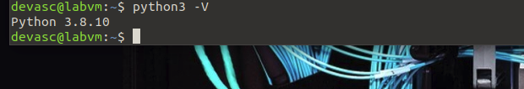

Answer 01 – Python Version

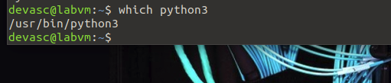

Answer 02 – Python Environment

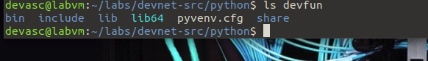

Answer 03 – Contents of the devfun directory

Answer 04 – New Virtual Environment

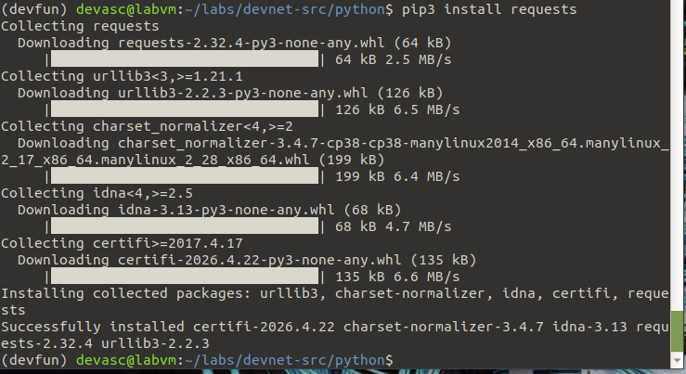

Answer 05 – Installing the requests package

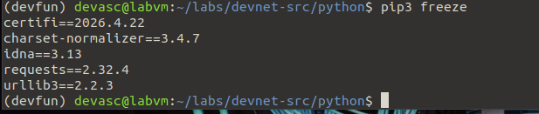
Answer 06 – List of packages and version as a result of a freeze

Answer 07 – Result of a deactivate command

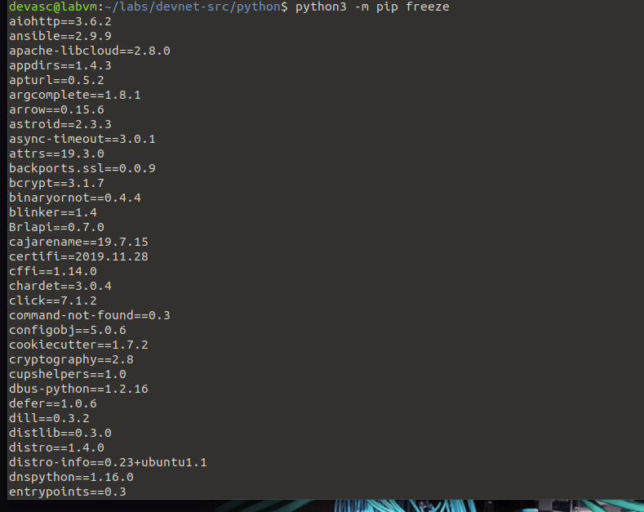
...
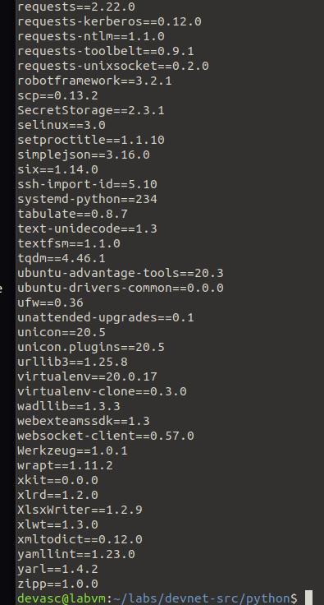

Answer 08 – List of packages and version as a result of a freeze

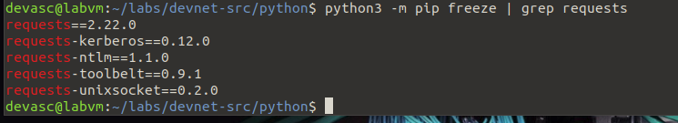
Answer 09 – View the requests values

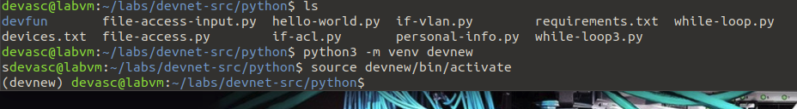

Answer 10 – New virtual environment and source

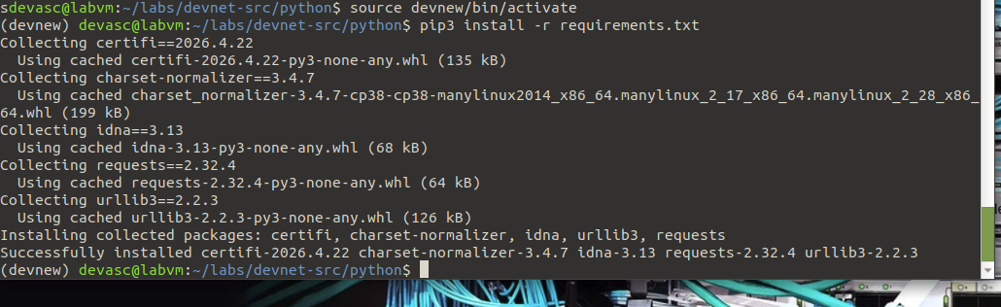

Answer 11 – Install contents of requirements.txt

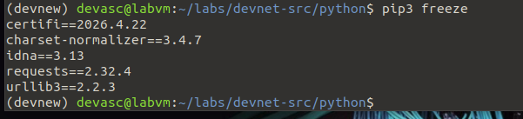
Answer 12 – List of packages and version as a result of a freeze

Answer 13 – Result after deactivating the virtual environment

